Machine Description | The Machine has remote code execution or credential abuse via vulnerable Tiki Wiki modules and exposed files leading to full system compromise.
Target IP | 10.22.169.205
Vulnerability Name | Tiki Wiki module remote code execution / authenticated command injection and credential disclosure chain.
Service and Version | TCP 80 / HTTP Apache  TCP 445 / SAMBA
CVSS Score and Severity | 9.8 Critical
Attack Vector | CVSS:3.1/AV:N/AC:L/PR:N/UI:N/S:U/C:H/I:H/A:H
Proof Of Concept | STEP 1 – Host discovery using Netdiscover Tool  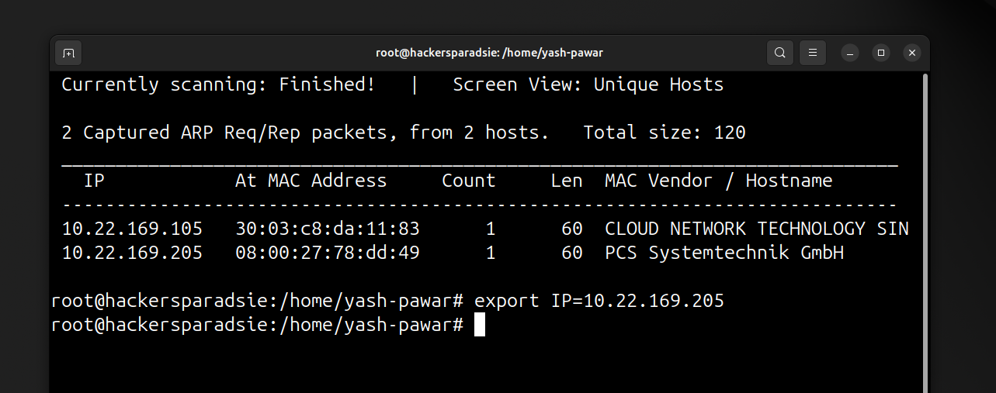  STEP 2 – Discovering Open ports and Services using Nmap  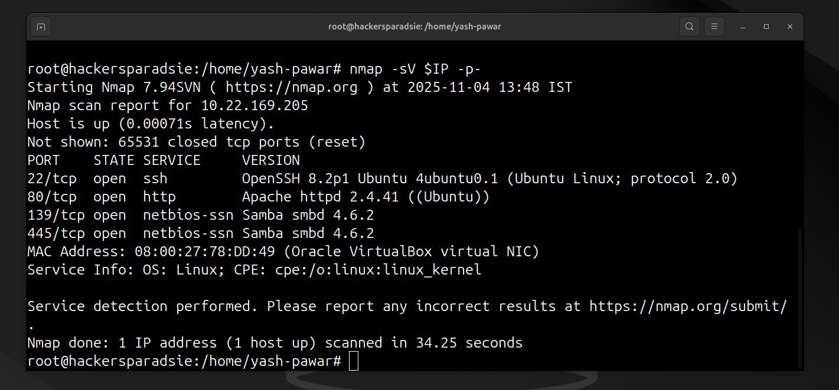  STEP 3 – Lets Enumerate Port 80 http  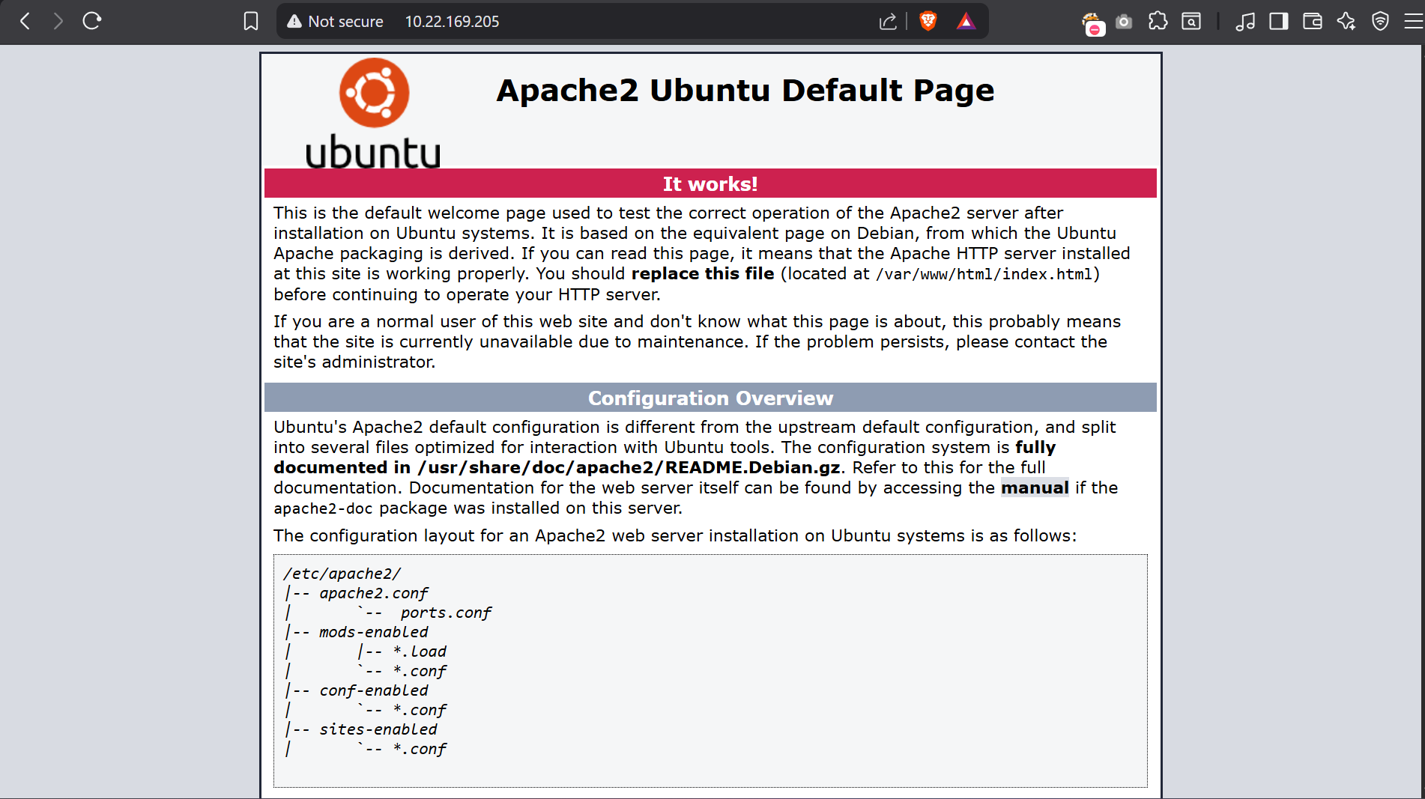  - Default apache page on server port 80 lets check for /robots.txt  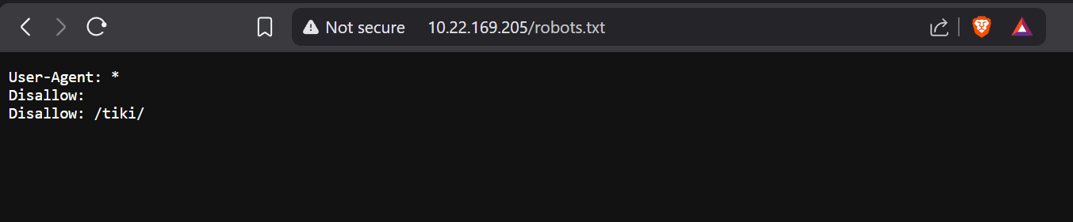  - It says Disallow /tiki lets visit it. Here we got default webpage for CMS and CMS login  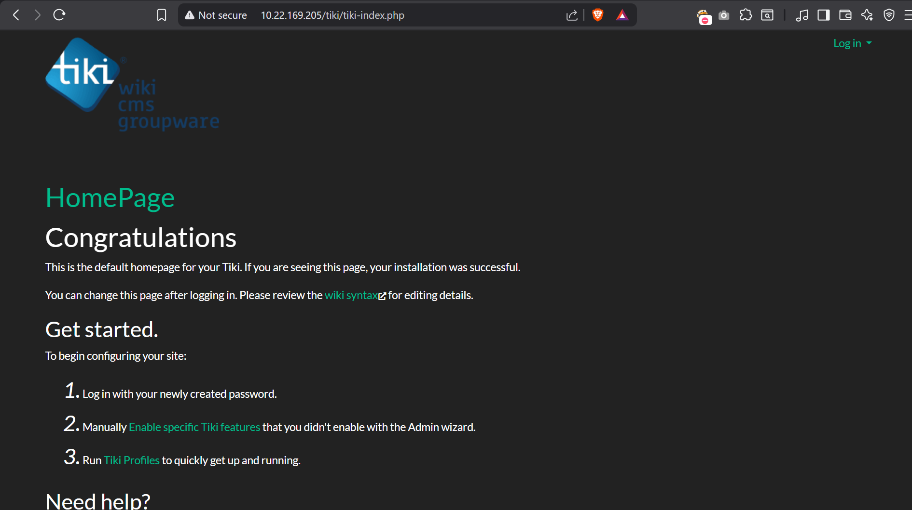  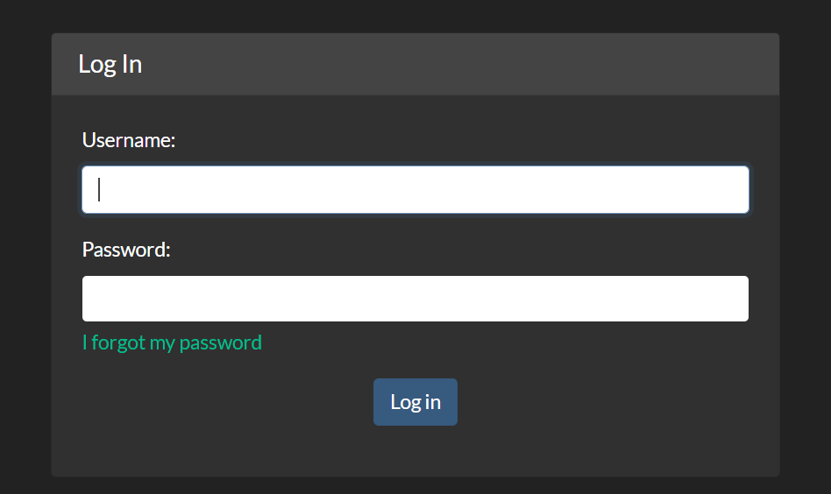  - We tried multiple things here we didn’t get much lets go for the SMB enumeration and find what we could get  STEP 4 – Look for if Null session possible and any open shares using Enum4linux  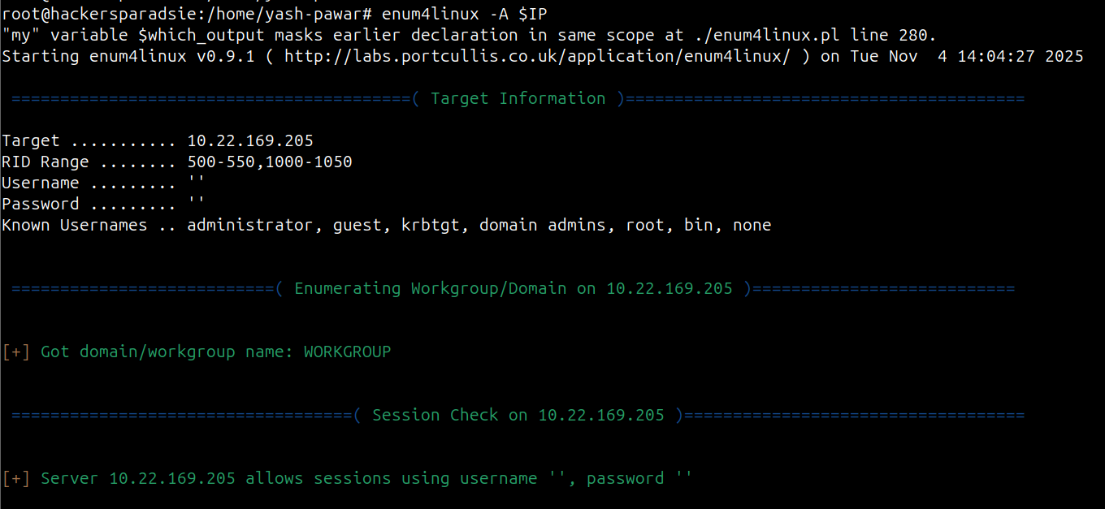  - It does allows null sessions lets list available shares ( -N for no password prompt and -L for list all available shares  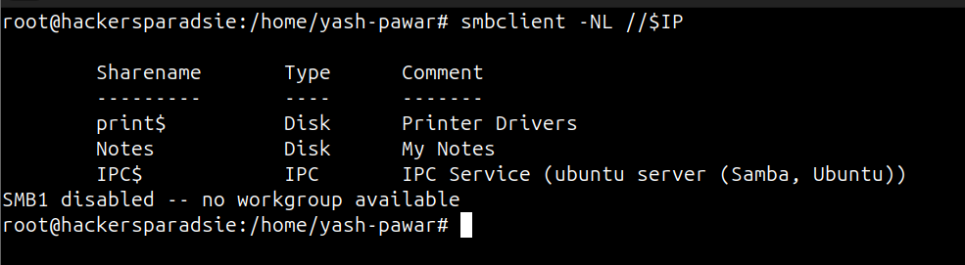  - Lets try to get null session login see what’s in Notes  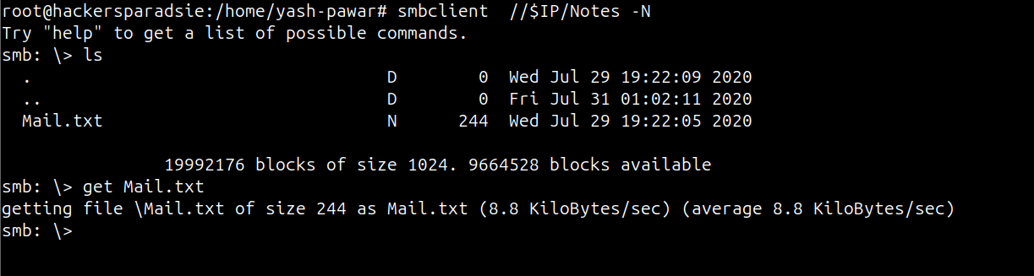  - We got file Name Mail.txt and user and pass for login ( Silky : 51lky571k1 )  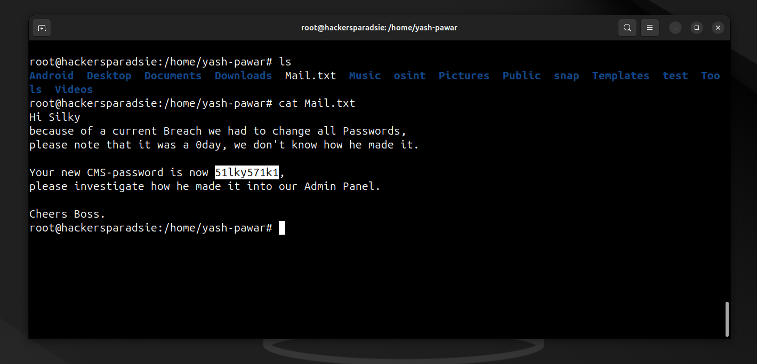  - Lets try to authenticate on CMS  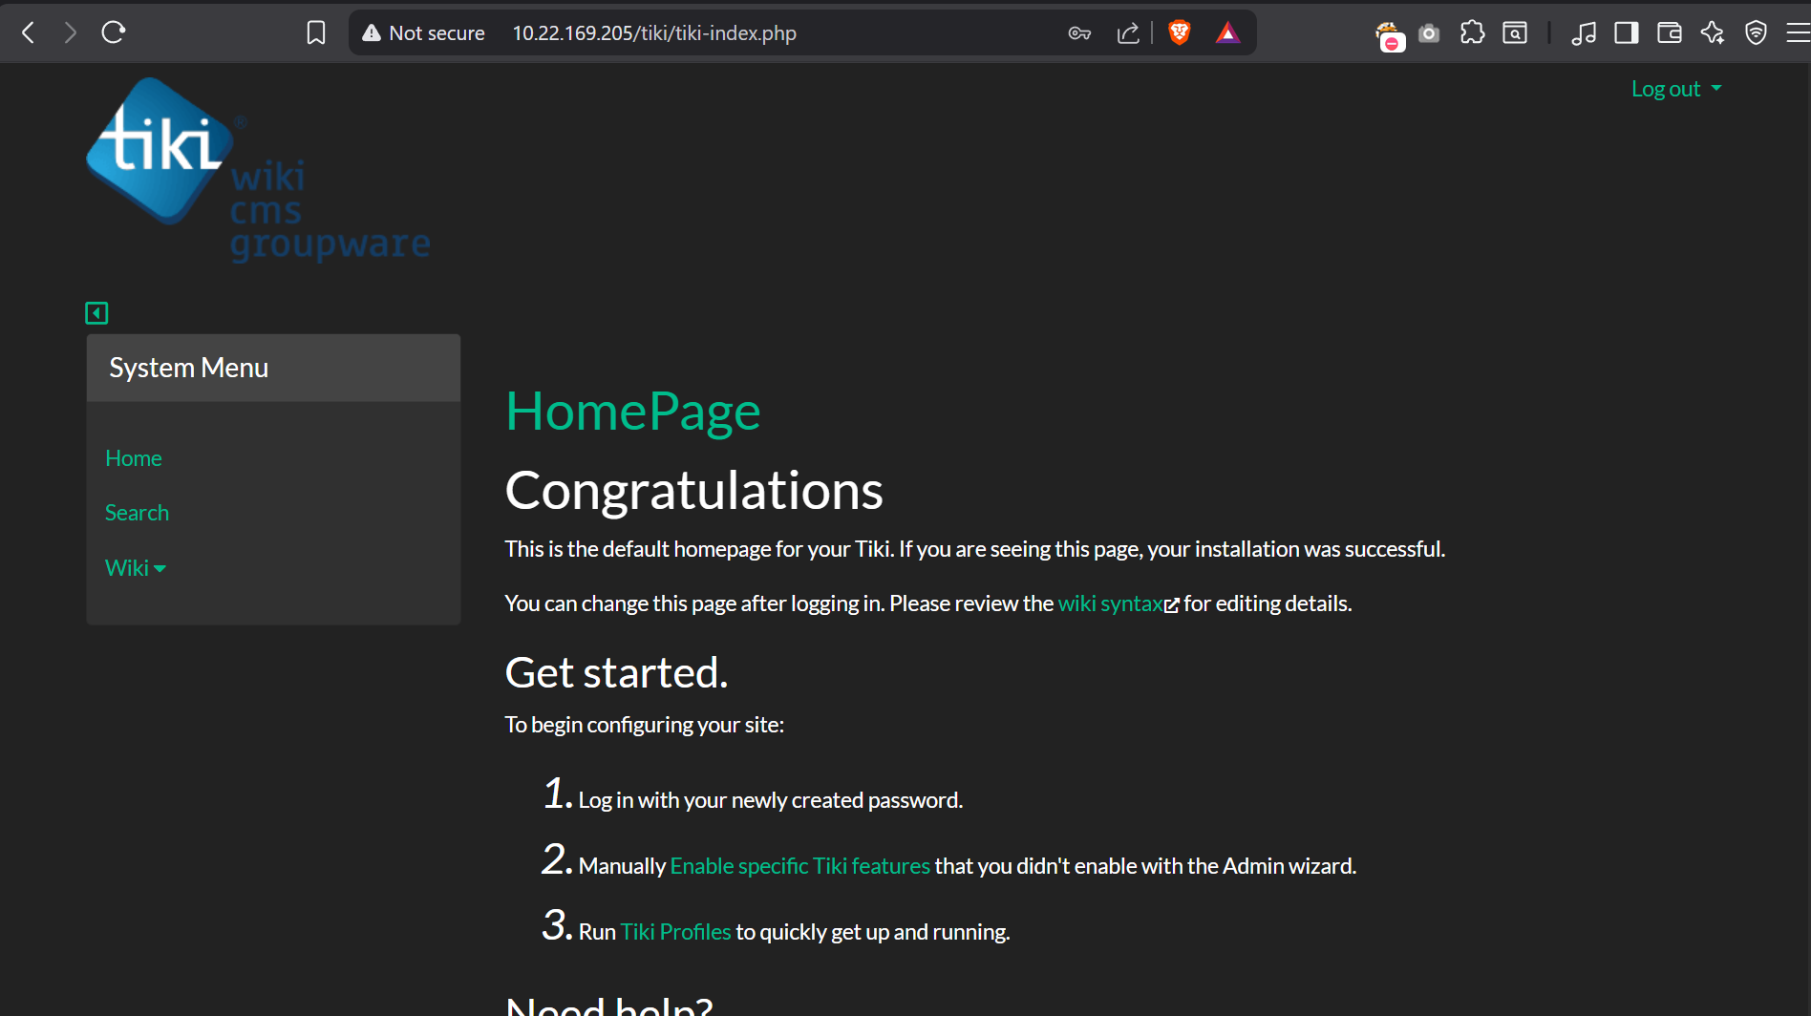  - We got Login Here after fuzzing we found here again /tiki/robots.txt and from here we visited /tiki/changelog.txt that most of the cms might have and where we got our version for CMS so it Version 21.1 lets try to find Exploit Code to abuse version  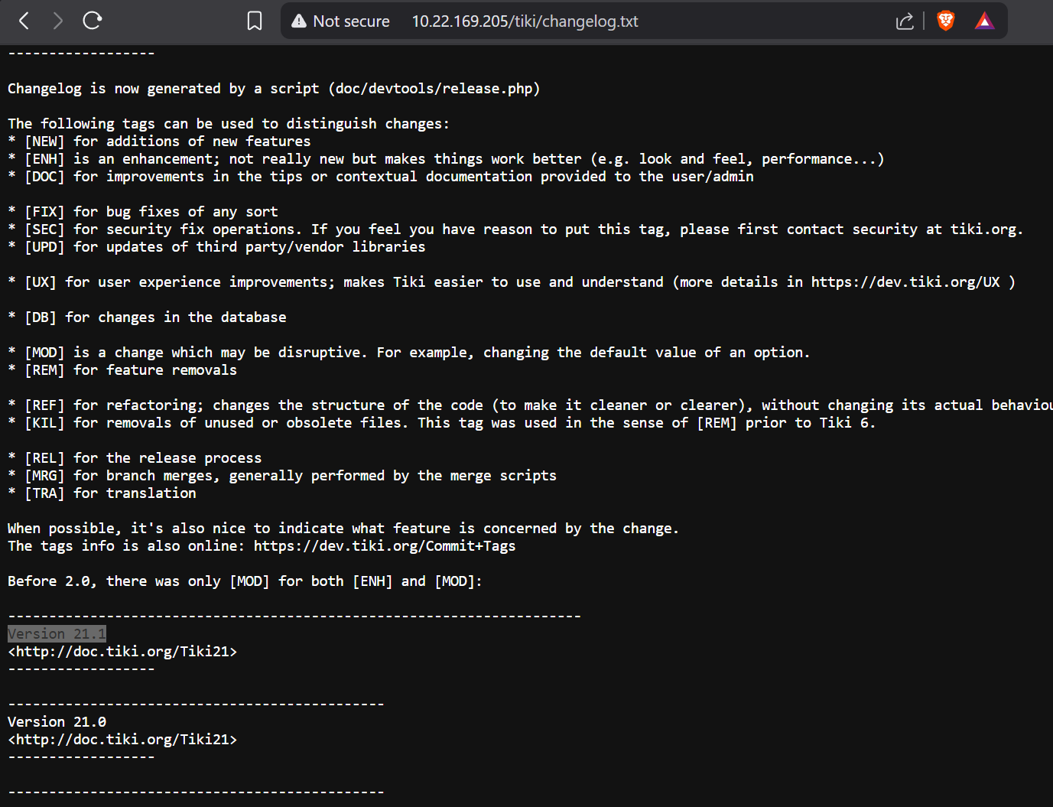  - Searchsploit tiki 21 so we do have one  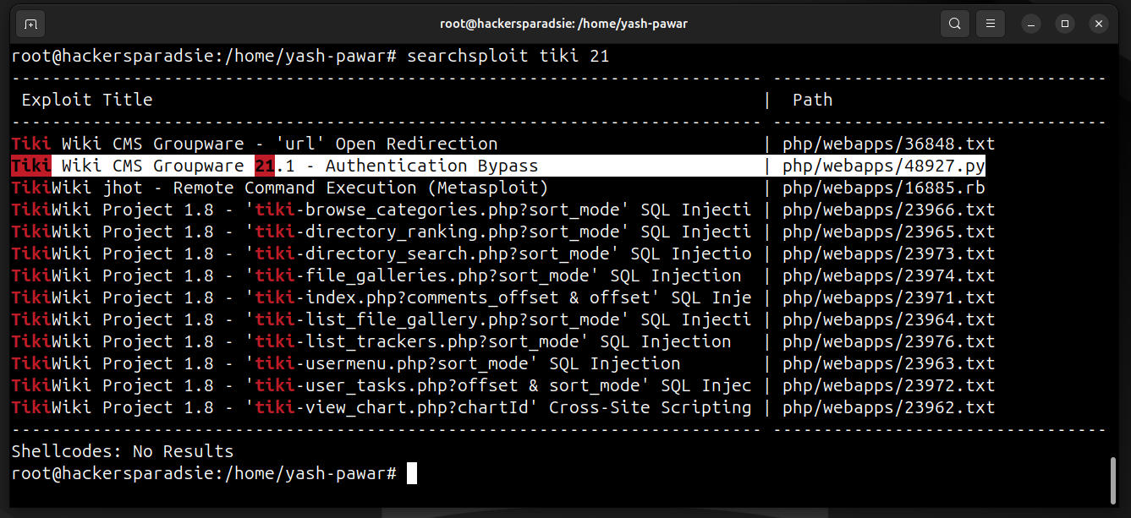  - Its simple to user not need to modify exploit  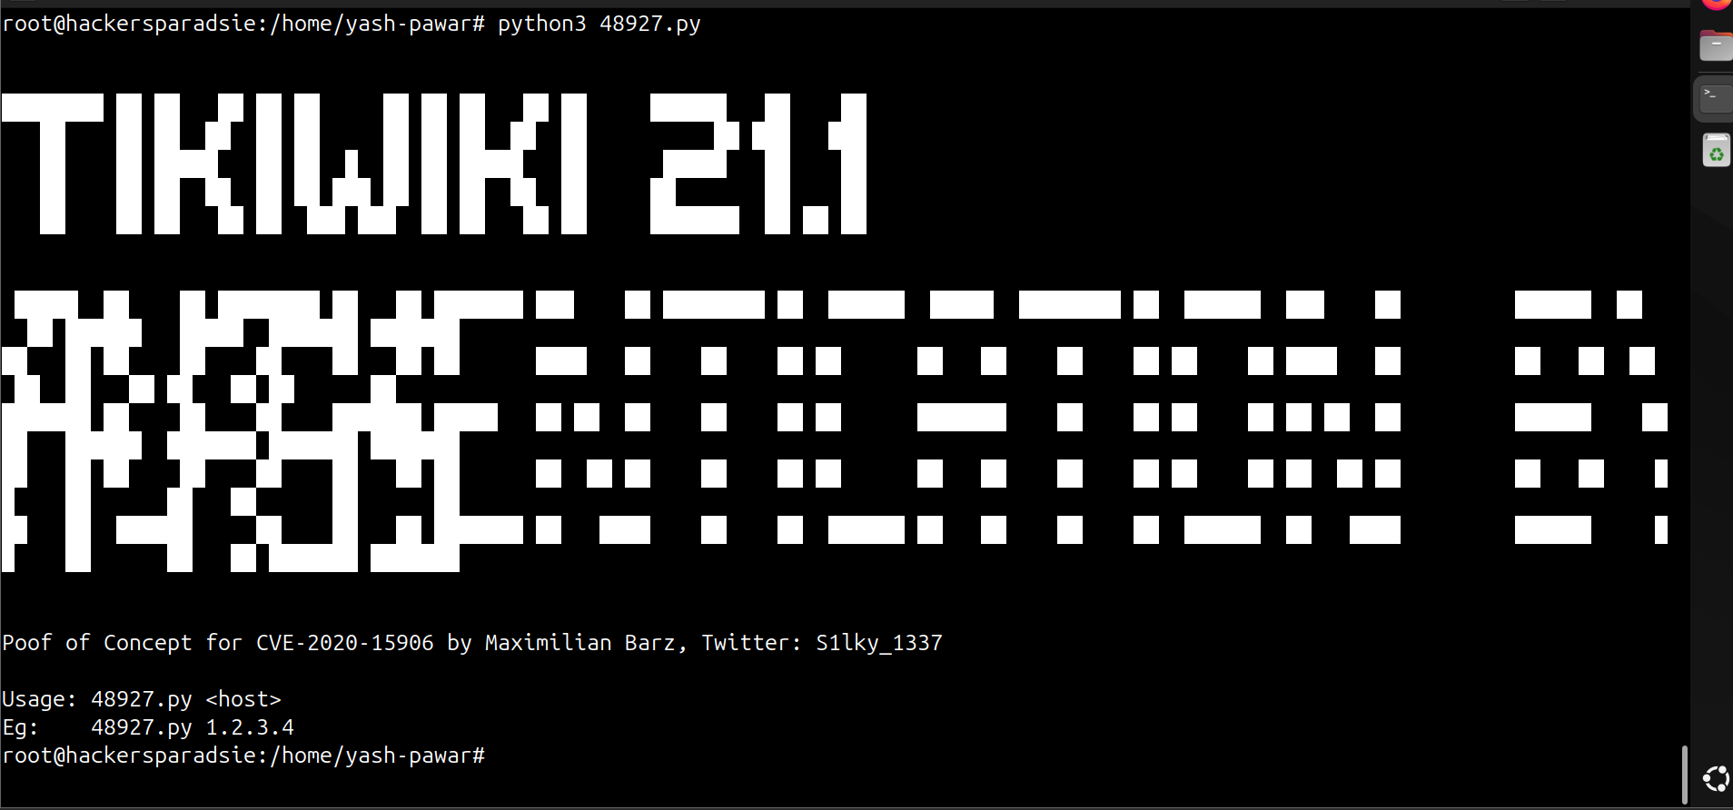  STEP 5 – Running Exploit Code  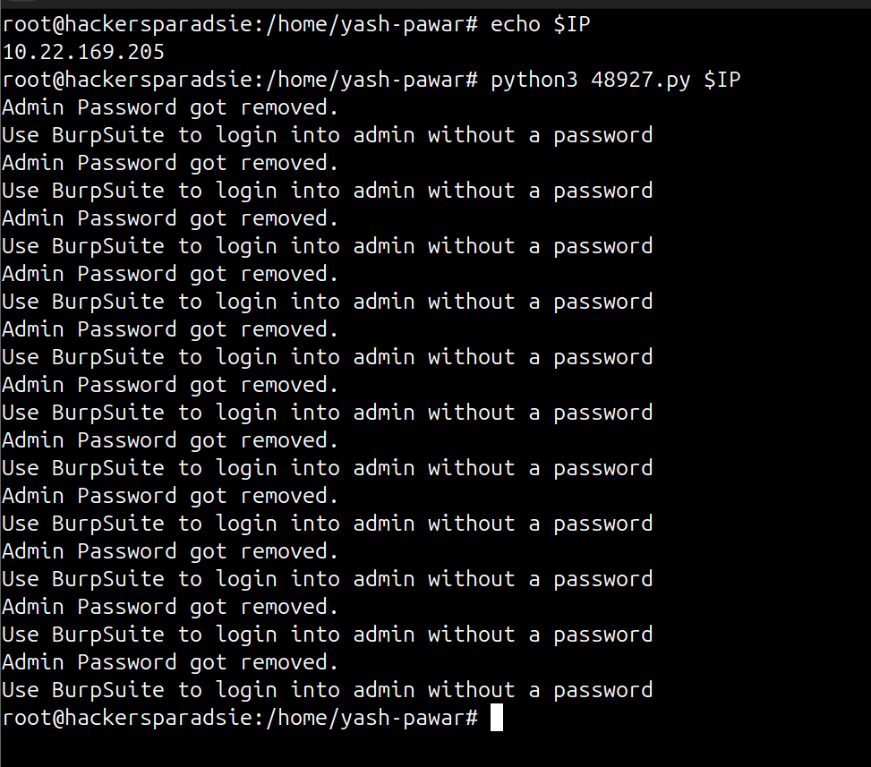  - We got authentication Bypass says Admin Password got Removed this it means we can user Burpsuite and pass empty password for user and we can get admin login  STEP 6 – Passing No password for admin user using burpsuite and trying to bypass authentication  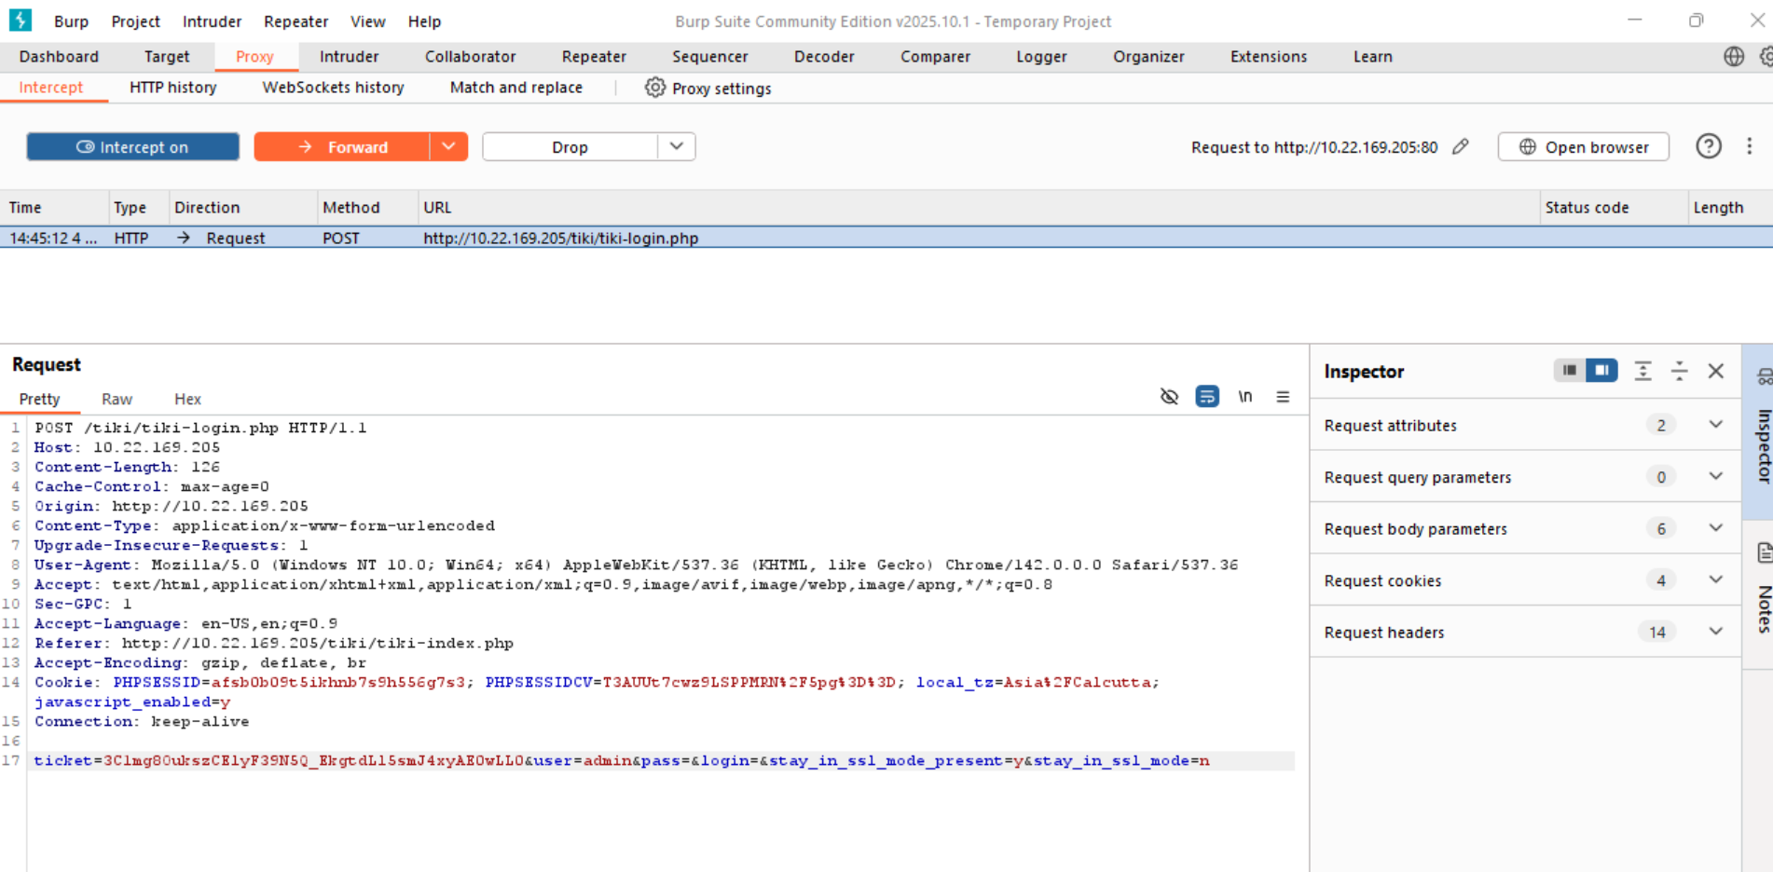  - We got Login as Admin  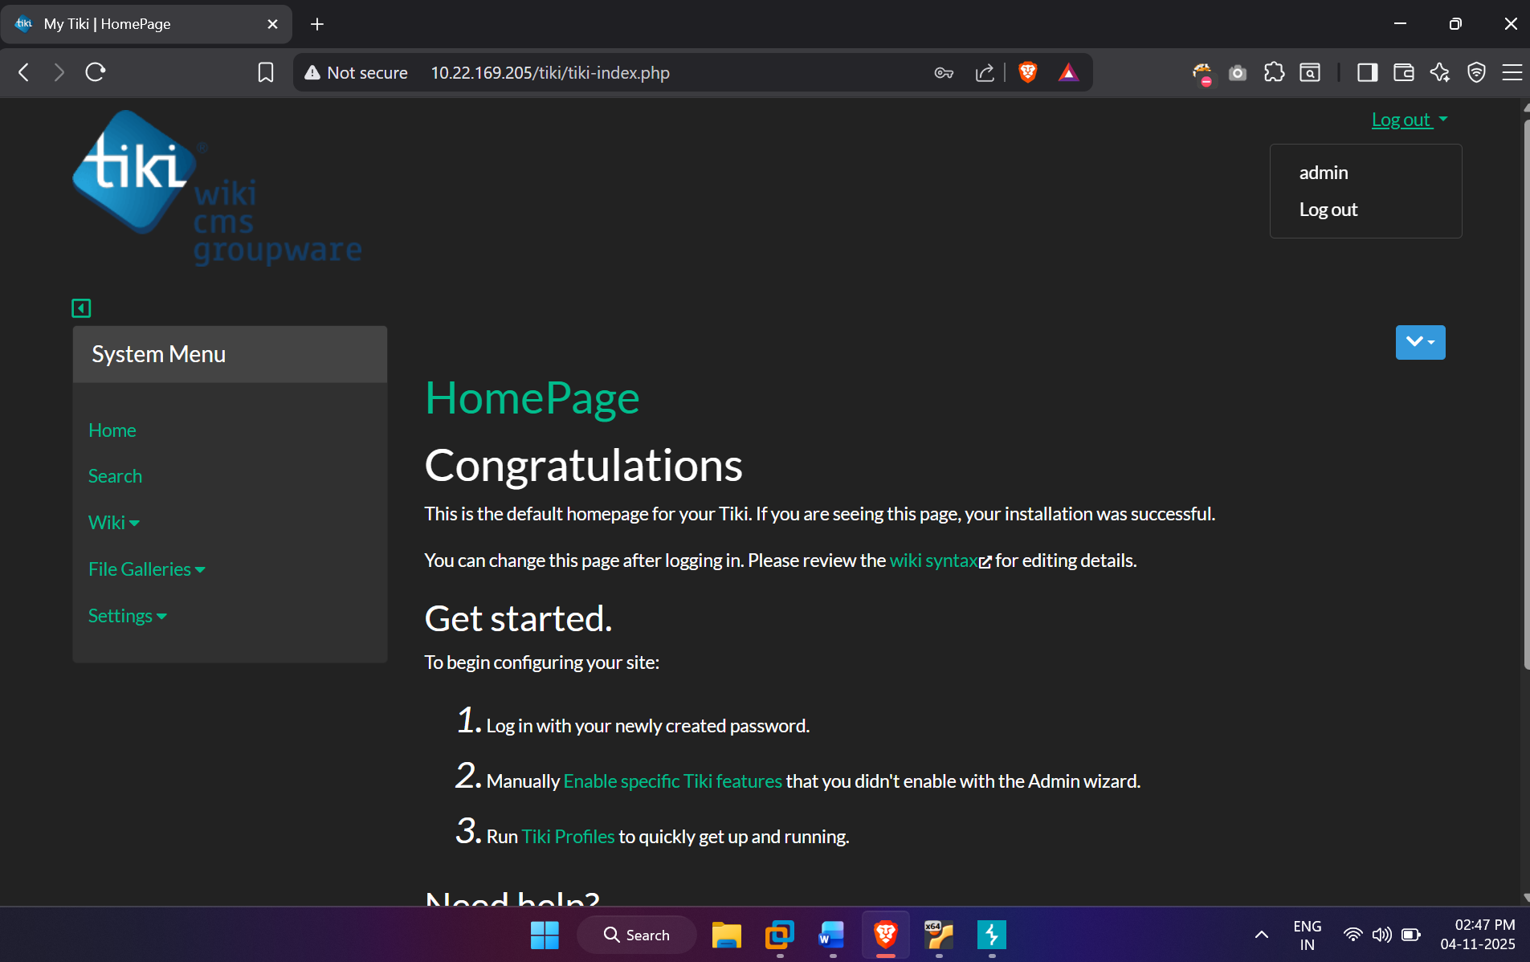  - After Some Hovering over the CMS we found Credentials for ssh login for user ( silky : Agy8Y7SPJNXQzqA )  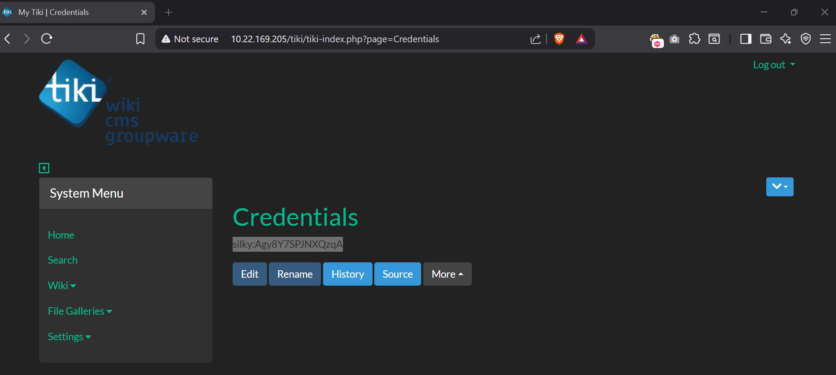  STEP 7 – Login Using SSH  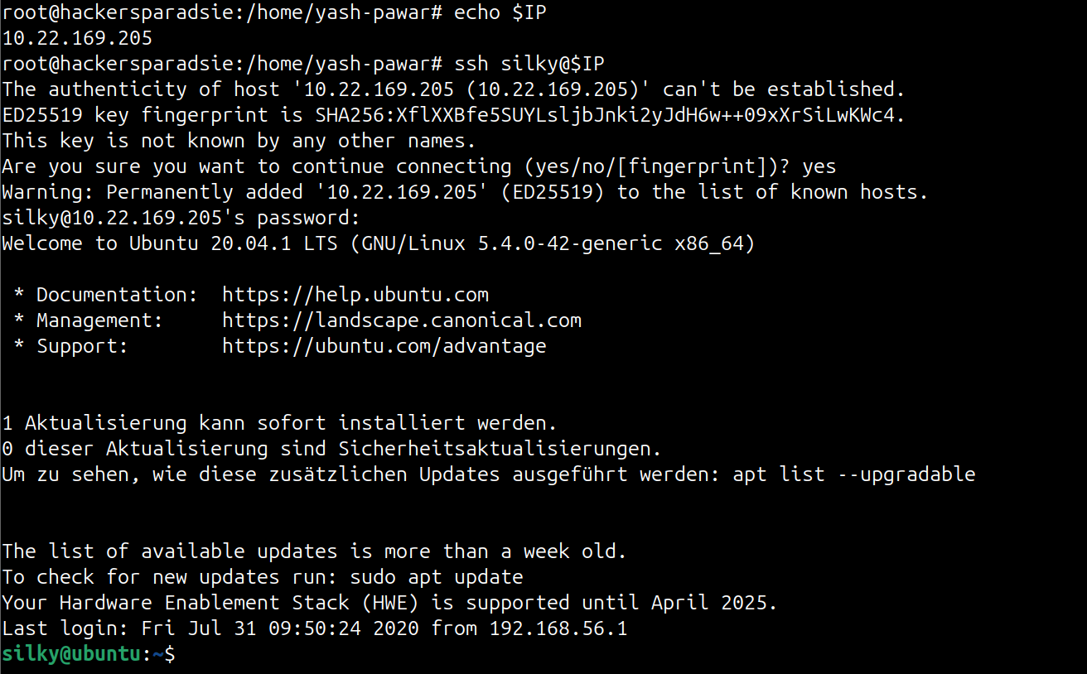  - List permission sudo -l we do have root perms for silky user  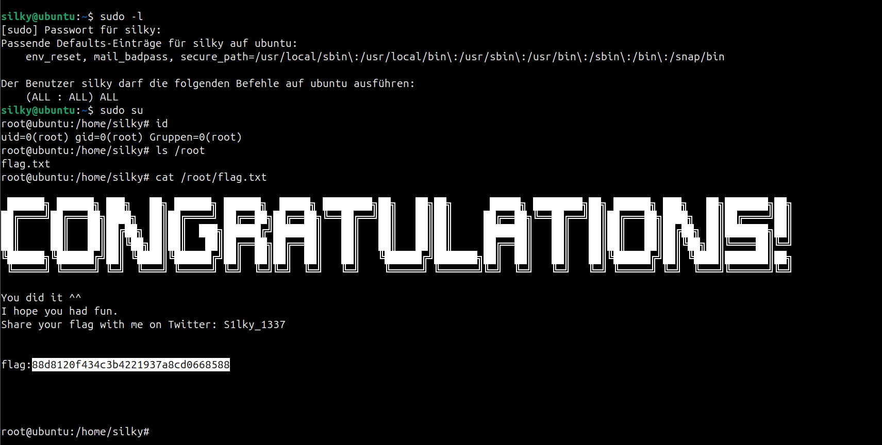  We Have solved The Machine
Impact | - attacker can obtain a remote shell running as the web user.  - sensitive files and credentials can be exposed and exfiltrated.  - attacker may use credentials and sudo misconfig to escalate to root.  - system integrity and availability can be fully compromised.
Remediations | - patch TikiWiki to a non vulnerable version and update all modules.  - remove or restrict unused modules and disable risky features like formula or calendar if unneeded.  - rotate exposed credentials and remove sensitive files from public shares.  - harden sudo rules and run webapp under least privilege and isolation.
Reference | https://nvd.nist.gov/vuln/detail/CVE-2020-15906

